

**Luminar Java Assignments:**

Student name: Manu K Shibu

Batch: ST NOV 2024 B1 Rakhi 2 pm-4pm

**Assignment_1:**

Check Whether a string contains vowels or not?

Code:

**package** stringMethods;

**public** **class** Vowels {

**public** **static** **void** main(String[] args) {

String str1 = "manu k shibu";

System.***out***.println("vowels in a string:");

**int** count = 0;

**for** (**int** i = 0; i < str1.length(); i++) {

// Checks whether a character is a vowel

**if** (str1.charAt(i) == 'a' || str1.charAt(i) == 'e' || str1.charAt(i) == 'i' || str1.charAt(i) == 'o'

|| str1.charAt(i) == 'u') {

// Increments the vowel counter

count++;

}

}

System.***out***.println("count of vowels: " + count);

}

}

Output:

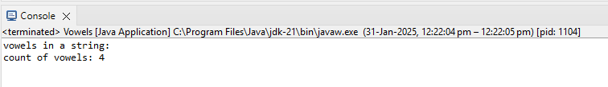

**Assignment-2:**

Find fibanoci series of number?

Code:

**package** basics;

**import** java.util.Scanner;

**public** **class** Fibanoci {

**public** **static** **void** main(String[] args) {

Scanner sc = **new** Scanner(System.***in***);

System.***out***.print("Enter the number of terms: ");

**int** n = sc.nextInt();

**int** n1 = 0, n2 = 1;

System.***out***.println("Fibonacci series:");

**for** (**int** i = 0; i < n; i++) {

System.***out***.print(n1 + " "); // Print the current term

**int** next = n1 + n2; // Calculate the next term

n1 = n2; // Update n1

n2 = next; // Update n2

}

sc.close();

}

}

Output:

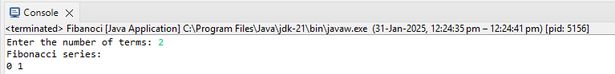

**Assignment-3:**

Check the Inputted Number is prime or not?

Code:

**package** basics;

**import** java.util.Scanner;

**public** **class** Prime {

**public** **static** **void** main(String[] args) {

Scanner sc = **new** Scanner(System.***in***);

System.***out***.println("Enter the number to check whether it is prime or not:");

**int** n = sc.nextInt();

**if** (n <= 1) {

System.***out***.println("Not a prime number.");

}

**int** count = 0;

**for** (**int** i = 1; i <= n; i++) { // Loop should run from 1 to n

**if** (n % i == 0) {

count++; // Increment count for each divisor

}

}

// Check if the number has exactly two divisors (1 and itself)

**if** (count == 2) {

System.***out***.println(n + " is a prime number.");

} **else** {

System.***out***.println(n + " is not a prime number.");

}

sc.close();

}

}

Output:

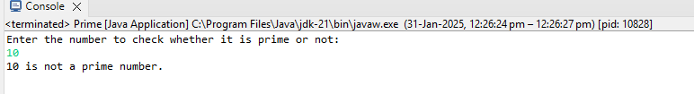

**Assignment-4:**

Find the Reverse of the given string?

Code:

**package** assigments;

**public** **class** Practice {

**public** **static** **void** main(String[] arg) {

String m1 = "MANU";

String reversedStr = "";

// Iterate through the string from last and add each character to variable

// reversedStr

**for** (**int** i = m1.length() - 1; i >= 0; i--) {

reversedStr = reversedStr + m1.charAt(i);

}

System.***out***.println("Original string: " + m1);

// Displays the reverse of given string

System.***out***.println("Reverse of given string: " + reversedStr);

}

}

Output:

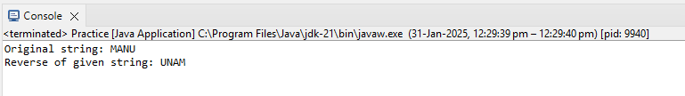

**Assignment-5:**

Find largest and smallest no in an Array?

Code:

**package** assigments;

**import** java.util.Scanner;

**public** **class** Practice {

**public** **static** **void** main(String[] args) {

Scanner sc = **new** Scanner(System.***in***);

// Input the size of the array

System.***out***.print("Enter how many numbers you want to input: ");

**int** n = sc.nextInt();

// Create an array to store the elements

**int**[] numbers = **new** **int**[n];

// Input the elements of the array

System.***out***.println("Enter " + n + " numbers:");

**for** (**int** i = 0; i < n; i++) {

numbers[i] = sc.nextInt();

}

// Display the array elements

System.***out***.println("You entered:");

**for** (**int** num : numbers) {

System.***out***.print(num + " ");

}

System.***out***.println();

// Find the largest and smallest elements

**int** largest = numbers[0];

**int** smallest = numbers[0];

**for** (**int** i = 1; i < n; i++) {

**if** (numbers[i] > largest) {

largest = numbers[i];

}

**if** (numbers[i] < smallest) {

smallest = numbers[i];

}

}

// Display the largest and smallest elements

System.***out***.println("Largest number: " + largest);

System.***out***.println("Smallest number: " + smallest);

sc.close(); // Close the scanner

}

}

Output:

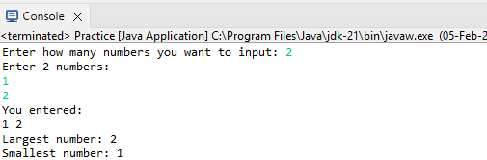

**Assignment-6:**

Reverse an array?

Code:

**package** assigments;

**import** java.util.Scanner;

**public** **class** Practice {

**public** **static** **void** main(String[] args) {

**int**[] a = **new** **int**[5];

Scanner sc = **new** Scanner(System.***in***);

System.***out***.println("Enter the elements:");

**for** (**int** i = 0; i < a.length; i++) {

a[i] = sc.nextInt();

}

**for** (**int** v : a) {

System.***out***.print(v);

}

System.***out***.println();

System.***out***.println("Reversed Array:");

**for** (**int** i = a.length - 1; i >= 0; i--) {

System.***out***.print(a[i]);

}

System.***out***.println();

sc.close();

}

}

Output:

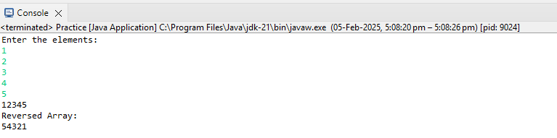

**Assignment-7:**

Sort array in ascending order?

Code:

**package** assigments;

**import** java.util.Arrays;

**public** **class** Practice {

**public** **static** **void** main(String[] args) {

// Define an array of integers

**int**[] numbers = { 5, 2, 9, 1, 5, 6 };

// Print the original array

System.***out***.println("Original array: " + Arrays.*toString*(numbers));

// Sort the array in ascending order

Arrays.*sort*(numbers);

// Print the sorted array

System.***out***.println("Sorted array: " + Arrays.*toString*(numbers));

}

}

Output:

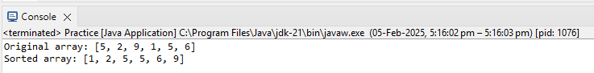

**Assignment_8:**

Code:

//Java Program to add two matrices

**package** assigments;

**import** java.util.Scanner;

**public** **class** Practice {

**public** **static** **void** main(String[] args) {

**int**[][] m1 = **new** **int**[3][3]; // Matrix 1: 3x3

**int**[][] m2 = **new** **int**[3][3]; // Matrix 2: 3x3

Scanner sc = **new** Scanner(System.***in***);

// Input elements for Matrix 1

System.***out***.println("Enter the elements of Matrix-1:");

**for** (**int** i = 0; i < 3; i++) {

**for** (**int** j = 0; j < 3; j++) {

m1[i][j] = sc.nextInt();

}

}

// Input elements for Matrix 2

System.***out***.println("Enter the elements of Matrix-2:");

**for** (**int** i = 0; i < 3; i++) {

**for** (**int** j = 0; j < 3; j++) {

m2[i][j] = sc.nextInt();

}

}

// Display Matrix 1

System.***out***.println("Array elements in Matrix-1:");

**for** (**int**[] outer : m1) {

**for** (**int** v : outer) {

System.***out***.print(v + " ");

}

System.***out***.println();

}

// Display Matrix 2

System.***out***.println("Array elements in Matrix-2:");

**for** (**int**[] outer1 : m2) {

**for** (**int** v : outer1) {

System.***out***.print(v + " ");

}

System.***out***.println();

}

// Add the two matrices

**int**[][] resultMatrix = **new** **int**[3][3]; // Resultant matrix after addition

**for** (**int** i = 0; i < 3; i++) { // Loop through rows

**for** (**int** j = 0; j < 3; j++) { // Loop through columns

resultMatrix[i][j] = m1[i][j] + m2[i][j]; // Addition logic

}

}

// Display the resultant matrix

System.***out***.println("Resultant Matrix after addition:");

**for** (**int**[] row : resultMatrix) {

**for** (**int** element : row) {

System.***out***.print(element + " ");

}

System.***out***.println();

}

sc.close();

}

}

Output:

